# User Manual

## Customer user Manual

This system also implement in localhost platform/environment. First of all insert I submitted CD Drive and it’s Install to any localhost server. Browse localhost/mycartshop.lk/mycartshop.lk

* First Browse my web site and Directly entered to my home to Page

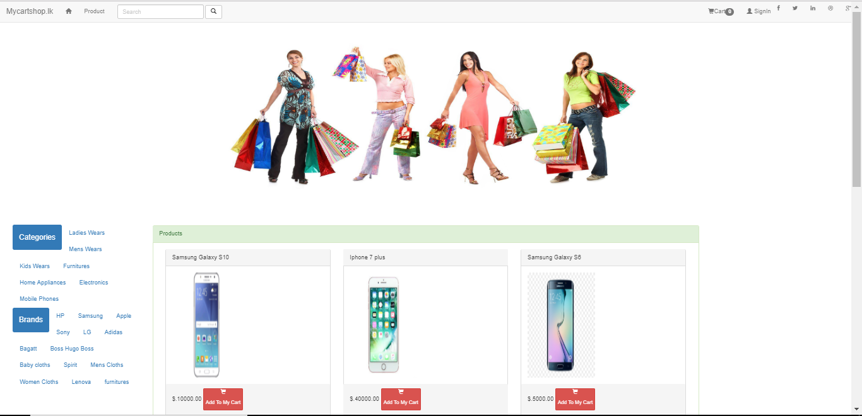

* If you want get every notification click notification button

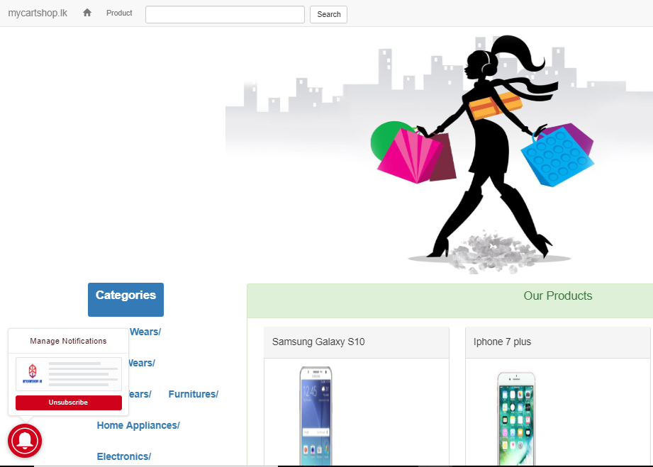

* Any requirements, discussion or Question with our team using chat panel

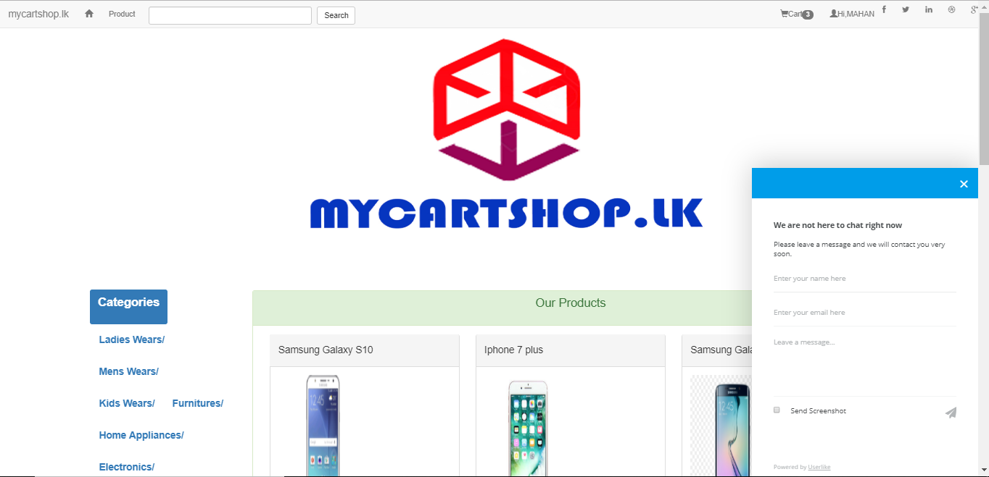

* Footer In the Website

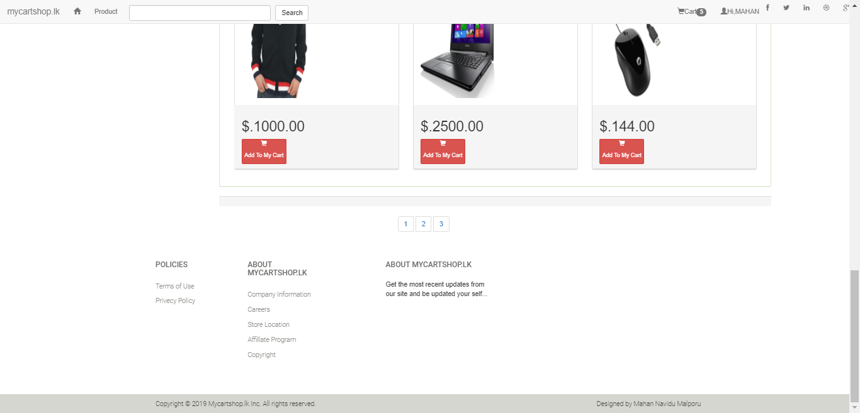

* Terms of Users in Footer in the web site after enter home icon

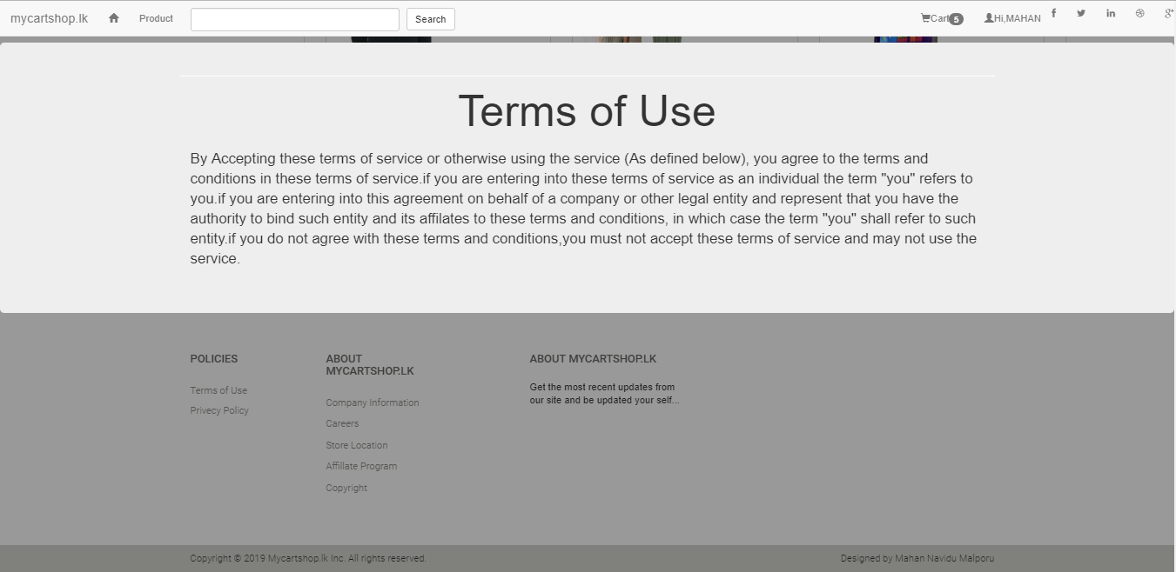

* Privacy Policy in Web site after enter home icon

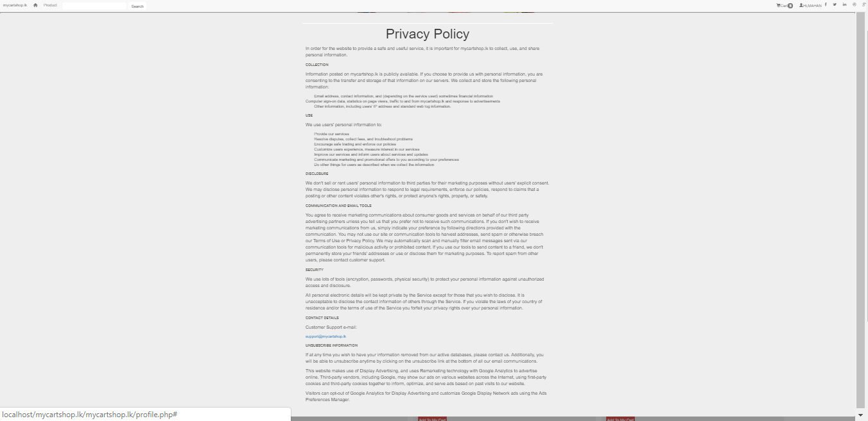

* Company information’s in Web site after enter home icon

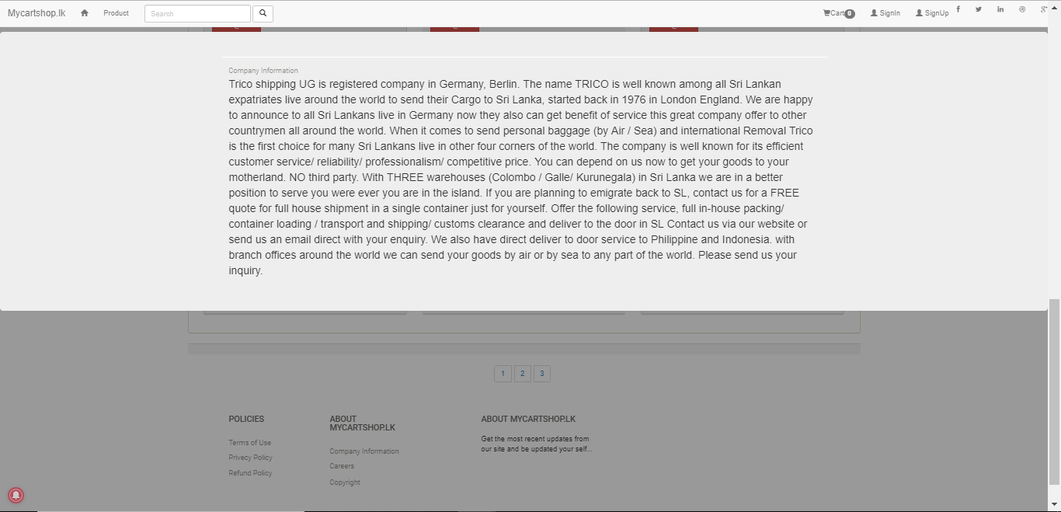

* Contact Us in Web site after enter home icon

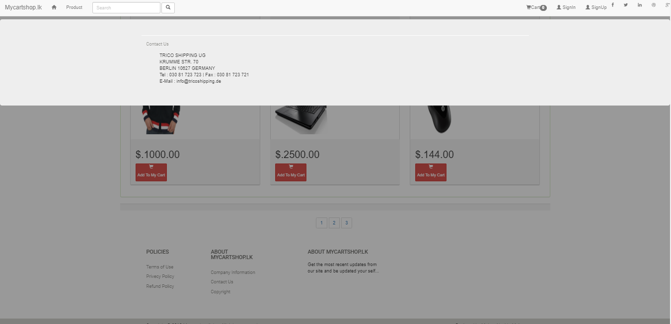

* If any product enter to cart click add my cart button click and products are add to the my cart

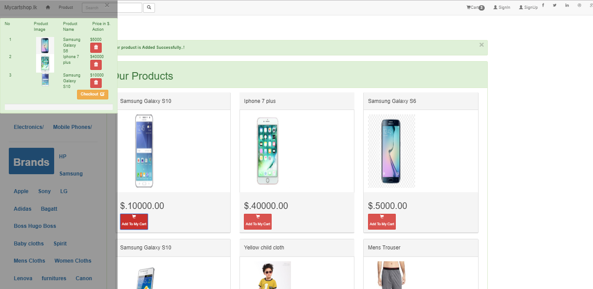

* Next Click the checkout button and next directed to my cart page

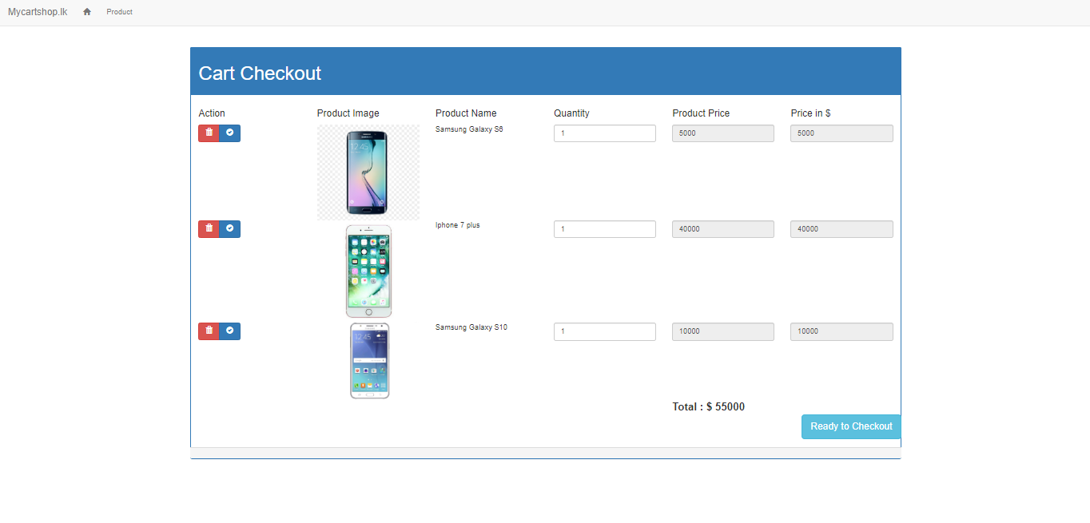

* If you not to login or signup next going to above page

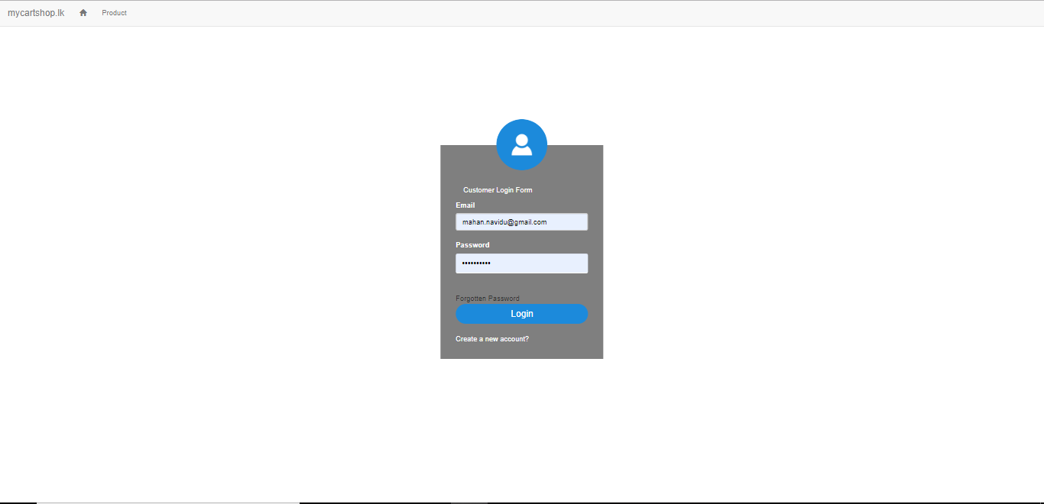

* If you not login to the system next enter create a new account

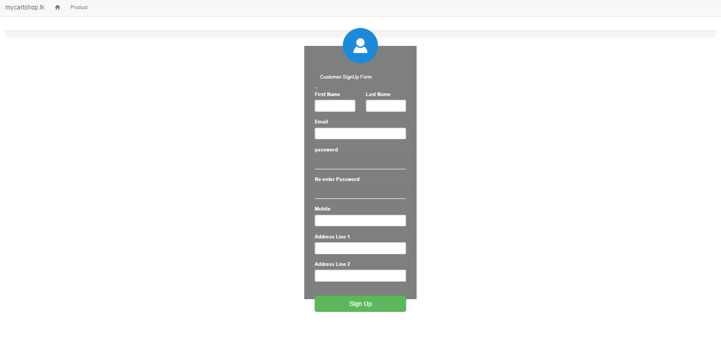

* Conformably signup/signing to the system enter product checkout page

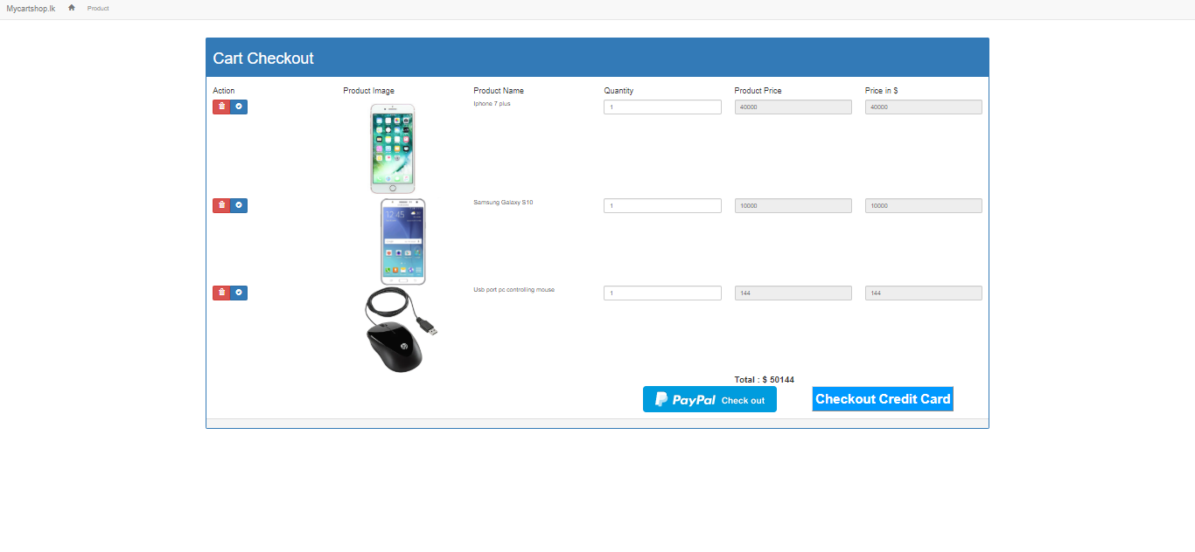

If you want edit items delete or update get action click delete button or update button

* Next Click PayPal directly going to sandbox.paypal.com declare transaction in PayPal account
* If you click checkout credit card directly going to the checkout page

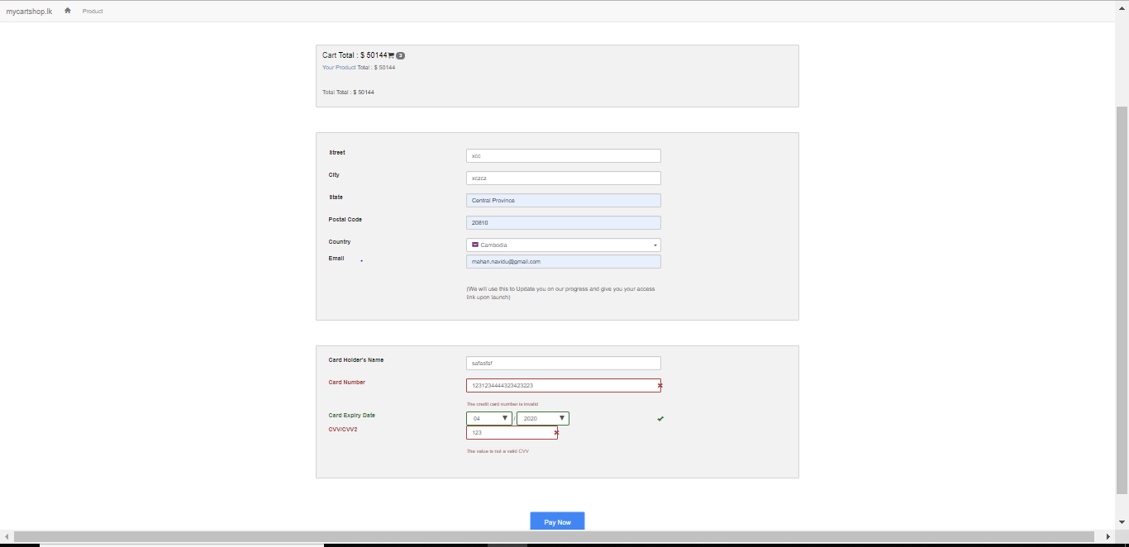

## Admin User manual

After the server installation localhost browse localhost/mycartshop.lk/mycartshop.lk/admin-1

First browse the admin page direction is browse to login page

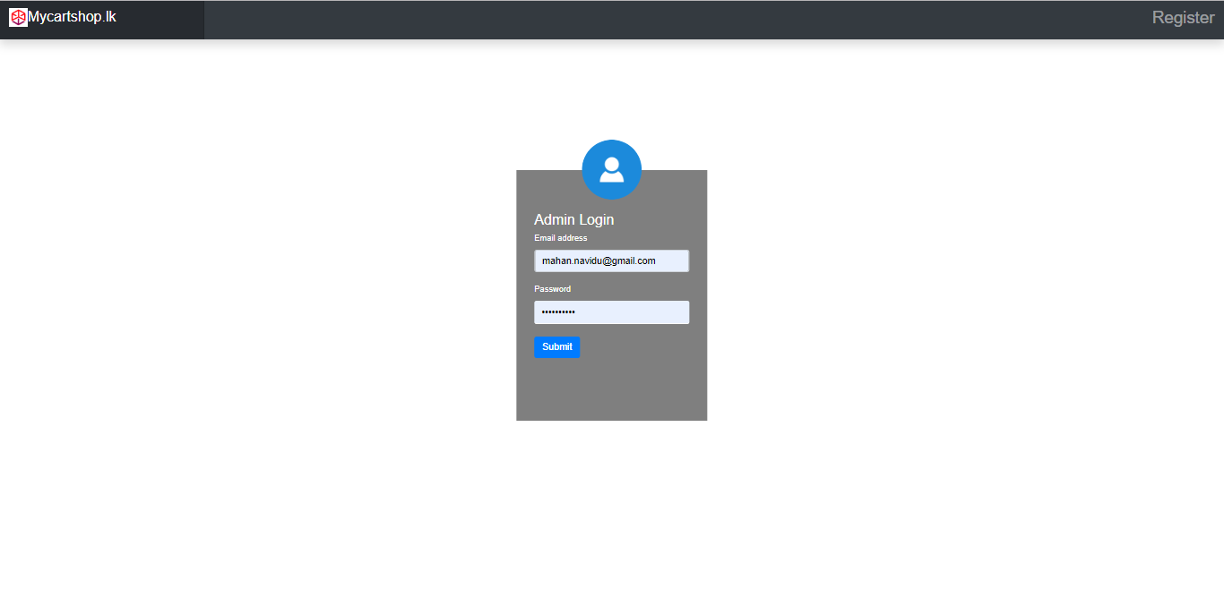

If you click the registration button loading registration page

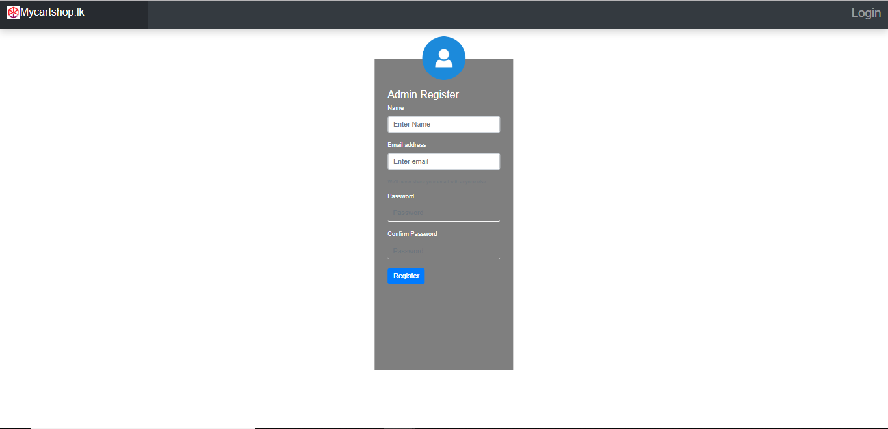

After the registration or Sign in to the system directly going to the dashboard

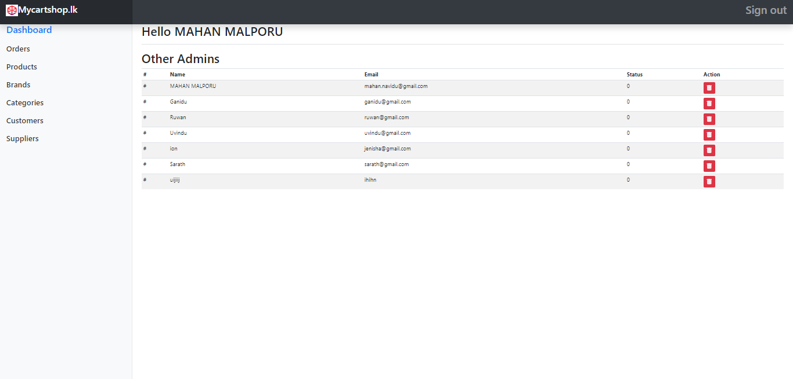

If you want to manager other admins get action in the action column

Next get manage the products click products in the side dashboard

If you want to add product fill the form and click add to product.

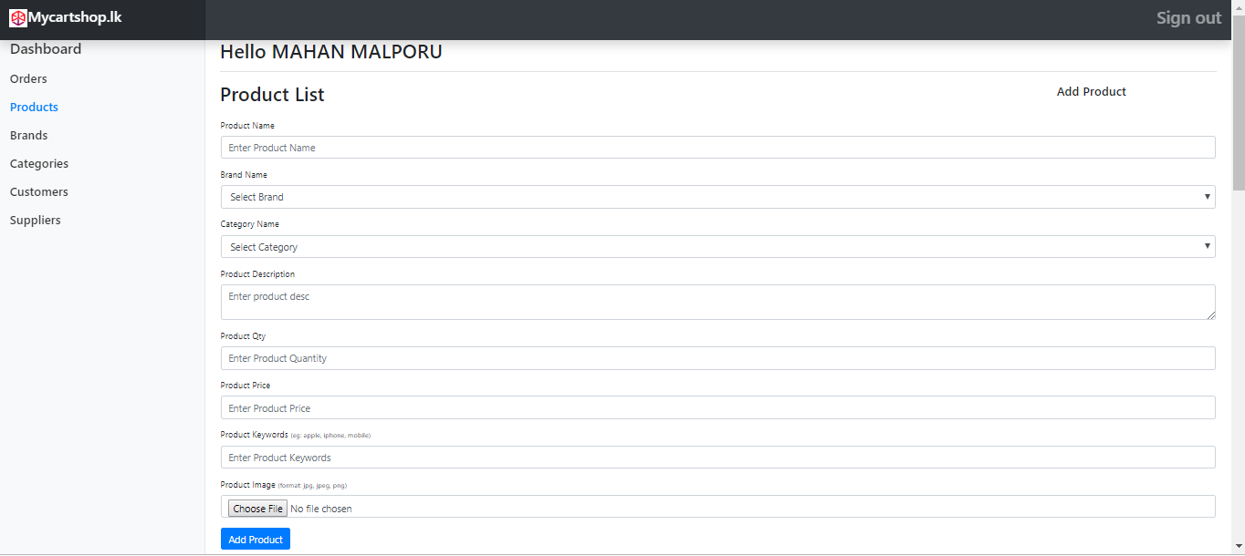

Scroll Down

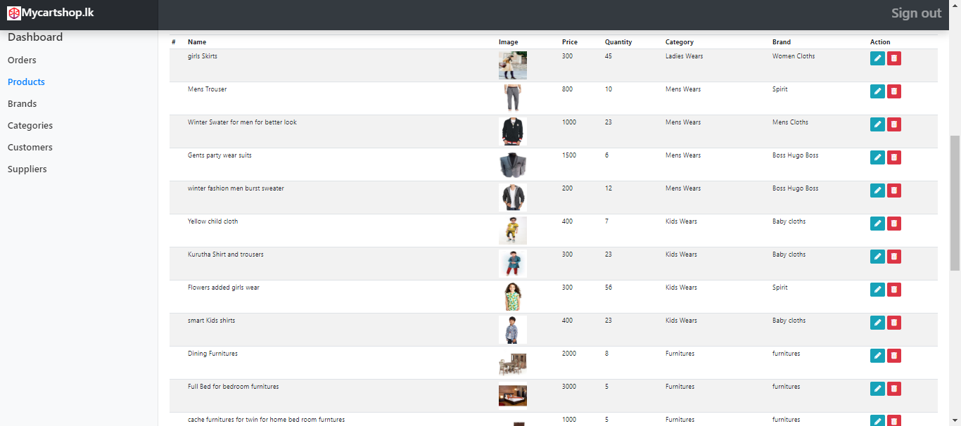

If you want to delete or update going to action bar buttons and get action

After click brands and add brands yet in the brands form want to update or delete brands going to the action bar and delete or update brands

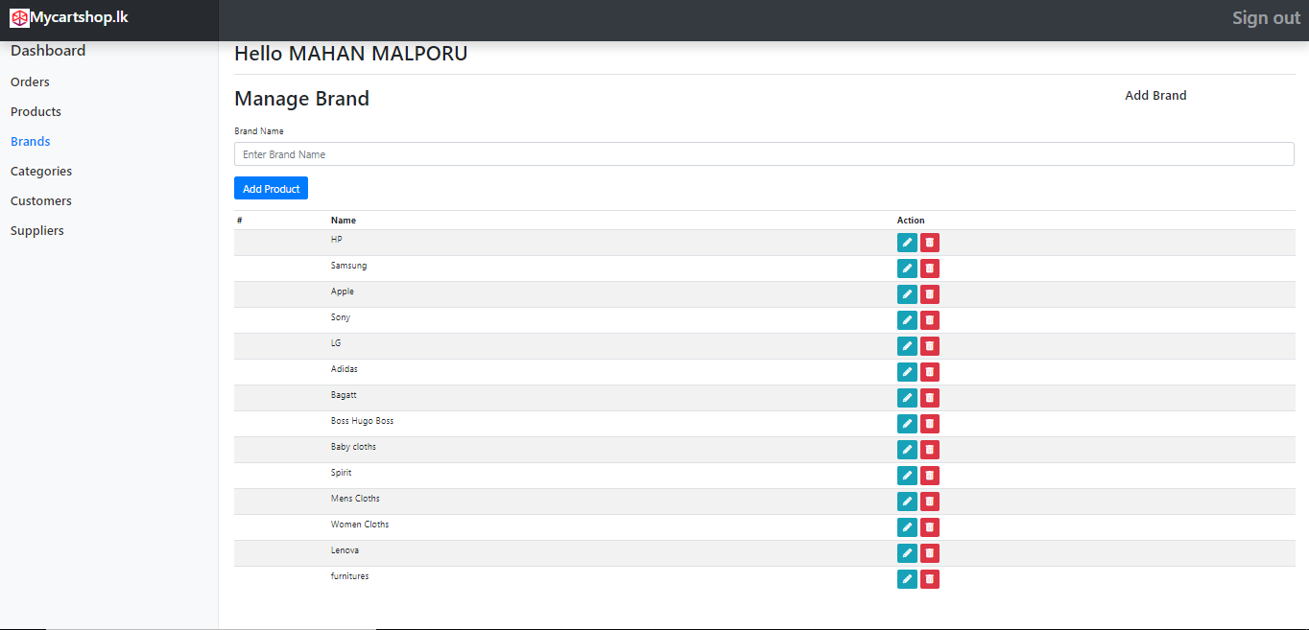

After click categories and add categories yet in the categories form want to update or delete categories going to the action bar and delete or update categories

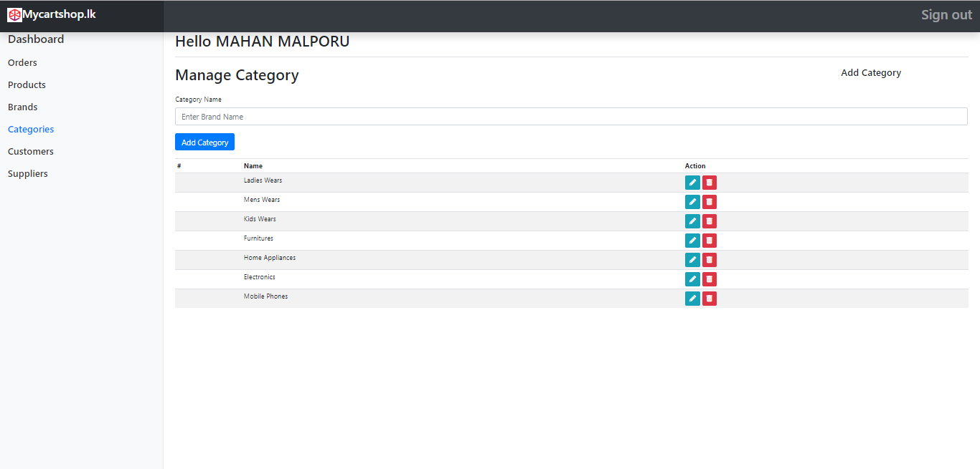

Administrator wants to get customer information going to the customer and get details

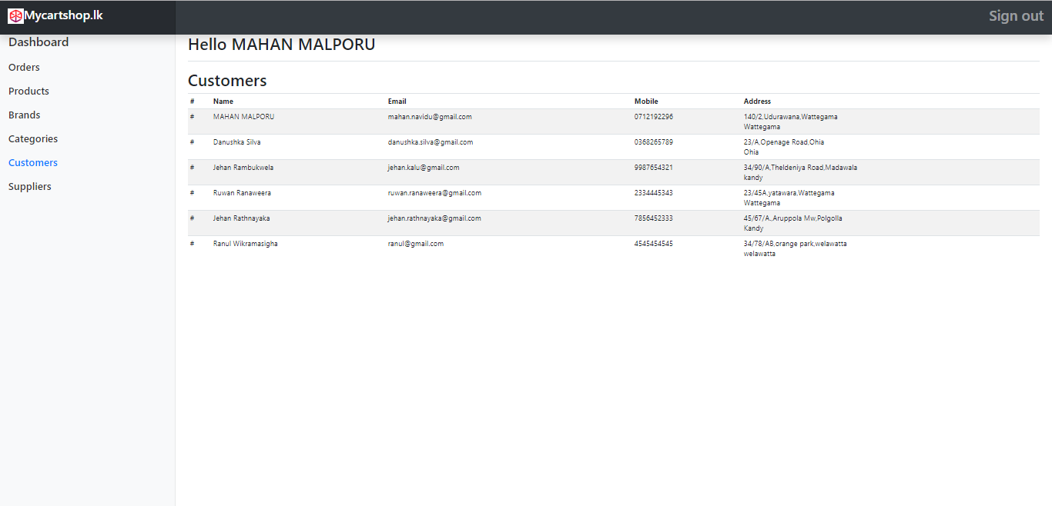

Administrator wants add supplier going to supplier form and add supplier next wants to update or delete supplier going to action bar and get action in action bar

